What he did  Abraham Lincoln opened the door to creating all men equal. He had worked hard his whole life to be good at what he did. He led this country and fought for all men to have the same rights. He didn’t end slavery, but he had tried his best to free those who were slaves. Thanks to him our country turned around for the better and we no longer see slavery like we used to. There are no long slave trades, or slave markets because of him and his fight to make all men equal.  Abraham Lincoln Gettysburg Address. |  |  | Abraham Lincoln  Take a Look at who I was  - By Ms. Williams
Abraham at Ford’s Theatre.
Table of Contents
Introduction 1
Who was in my family 2
What was life like before Presidency 3
My hardships my family faced 3
My accomplishments as a President 4
How the Story Ended 4
5

Accomplishments  Honest Abe was elected president in 1861. During his presidency he gave the well-known speech called the Gettysburg Address. He passed the emancipation proclamation. Which stated that if you were a slave you were to be free, whether in the north or the south. He was reelected for a second term and the Civil War ended.  “A house divided cannot stand.”  Assassination  The Lincoln family was out for a night of theatre when disaster struck. They were at Ford’s Theatre when John Wilkes Booth shot Abraham in the back of the head. Abraham was in a coma for nine hours and then died early the next morning.  John Wilkes Booth  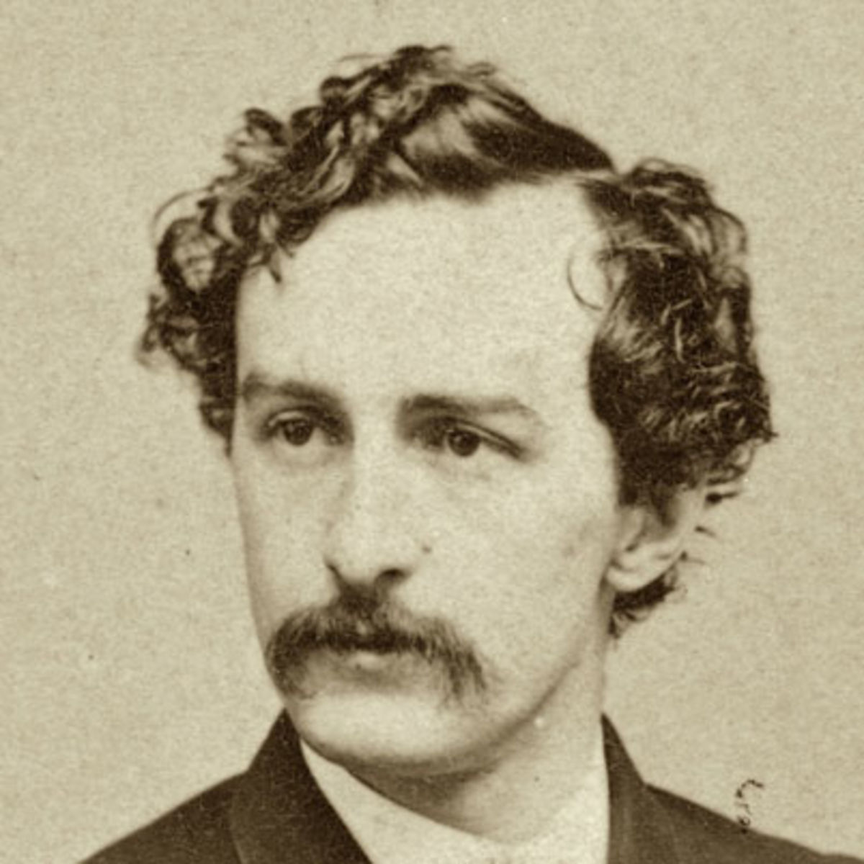 |  |  | Introduction  Quick Insight  Abraham Lincoln was born February 12, 1809. He moved around a lot with my family and lost my mother when Lincoln was young. He had a small family and he later married making my own family. Abe pursued his law career once he moved to New Salem, IL on his own, then he became the 16th president running against Stephen Douglas. As a family the Lincoln’s faced a lot of hardships, but becoming president was a great reward.  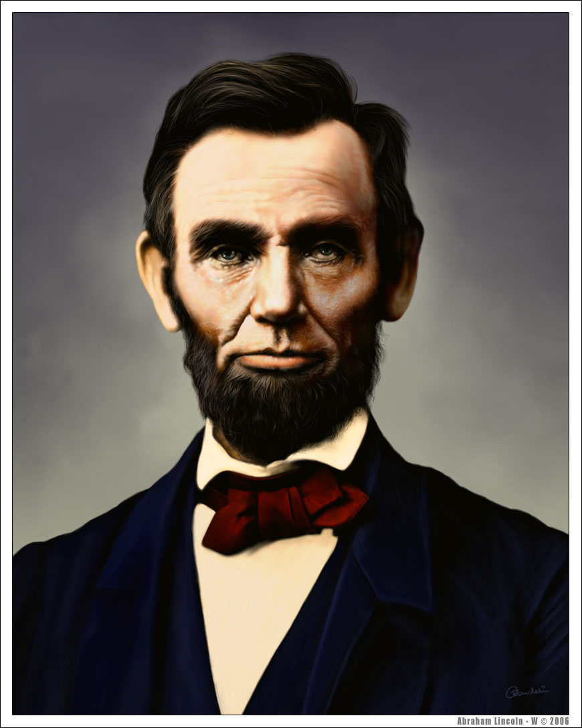
4 |  |  | 1

My Family  Growing up  Lincoln born in Hodgenville Kentucky. He lived there until I was eight with my father Thomas, mother Nancy Hanks, and sister Sarah. They then moved due to a land dispute, taking the family too Indiana, where his father remarried to Sarah Bush Johnston.  “Nearly all men can stand adversity, but if you want to test a man's character, give him power.”  Abe and Mary’s Family  Lincoln engaged to a few women after the death of Anne Rutledge whom he thought would be his one and only. He later met Mary Todd in 1840. They were later married in 1842. Lincoln had four lovely children with Mary Todd. Robert Todd their first born son, Edward Baker their second son, Williams Wallace, and their last Thomas “Tad” Lincoln. Edward, William, and Tad didn’t survive. Edward or Eddie was only 4 years old when they had to say goodbye. William or Willie was 12 years old, he was also the first child to die in the White House. Tad died when he was 18 and out on his own. |  |  | Once Lincoln moved to New Salem he had many different jobs, a shoe maker, and a postmaster. He eventually owned his own general store, which is how he learned to have the social skills he did. Once a war broke out he was elected to become their captain. After that war he began his political career and become and Illinois State Legislature. 1834 he was a member of the Whig party. In 1837 he was admitted for the bar exam and then moved to Springfield, IL to start his lawyer career.  The Hardships  Abe’s family heartache  Abe and his family. Lincoln’s mother died of cancer and it took her life when he was nine. He was raised by his father and then shortly his father remarried and he was then raised by Sarah Bush Johnston. Abe and Mary’s second son Edward died from tuberculosis a month before his fourth birthday. Their third son Willie died of Typhoid when he was 12, Tad also got the typhoid fever, but survived at the time. Tad later died when he was 18. Not only was death big during this time, but Lincoln and his family had to go through the election process. He faced Stephen Douglas in 1857 where he told Stephen the Supreme Court and President Buchanan they were wrong for supporting slavery.
2 |  |  | 3

